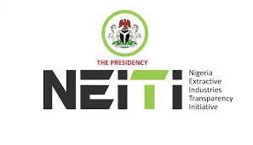

INCEPTION REPORT

OIL AND GAS INDUSTRY AUDIT 2022-2023

AN INDEPENDENT REPORT ASSESSING AND RECONCILING PHYSICAL AND FINANCIAL FLOWS WITHIN NIGERIA’S OIL AND GAS INDUSTRY

Prepared By

April 2024

Table of Contents
List of Figures iii
List of Tables iv
Abbreviations and Acronyms v
1.0. Background 1
  - Introduction 2
  - Objectives of the Assignment 3
  - Basis, Currency, and Period of the EITI Reporting 5
    - Basis of the EITI Reporting 5
    - Currency and Period of the EITI Reporting 5
  - Scope of Work 6
  - Overview of Covered Entities in the Current Reporting Period 7
  - Timeline and Deliverables 7
  - Approach and Methodology 13
    - Approach and Methodology: 2023 EITI Validation Gap 13
    - Approach and Methodology: 2022 and 2023 EITI Reporting Process 18
1.8 Overview of the Oil and Gas Regulatory Framework in Nigeria 21
  - Independent Administrator’s (IA) Assessment of the NSWG Material Decision 46
  - IA Comments on the Materiality Decision 46
3.0. Data Quality, Assessment, and Confidentiality 47
  - Basis of Data Quality, Assessment and Confidentiality 47
  - Comment on the Assessment Procedure and Documentation for Data Quality 47
  - Comment on Data Collection Templates, Tools and Strategies 48
4.0. Preliminary Activities and Audit Planning 49
  - Discussion on Work Done 49
  - Initial Observation and Expectations 50
    - Crude Oil Production 50
    - Product Importation and Local Production 51
    - Contribution of the Oil and Gas Sector to the Economy 52
    - Overview of NNPCL Projects and Timelines 55
    - Systematic Disclosure 58
4.2.5.1 Government Entities 58

Annexes
- Terms of Reference
- NEITI NSWG Materiality Decisions
- Project Implementation Schedules
- NUPRC Production Data: 2022 and 2023
- Overview of NNPC Project and Timelines
- Product Imported and Distributed
- Pre-Engagement Meeting Presentation on the Overview of the Audit Approach and Methodology.
- Audit Templates
- Audit Checklist
- Schedules of Covered Entities (Companies and Government)

List of Figures
Figure 1: EITI Standard: Summary of Changes 2
Figure 2: EITI Process 6
Figure 3: Summarised Audit Approach 6
Figure 4: Overview of the Key Stakeholders in the Oil and Gas Industry 7
Figure 5: 2022-2023 OGA EITI Reporting Process Timeline 7
Figure 6: Data Quality Lifecycle 47
Figure 7: Aggregate Production Data – Million Barrels 50

List of Tables

Table 1: Core Components of EITI Implementation 1
Table 2: Objectives and Work to Be Undertaken by IA 3
Table 3: CBN Average Exchange Rate for the 2022-2023 Oil and Gas Industry EITI Reporting . 5 Table 4: Reporting Deliverables 8
Table 5: Proposed Action to Support NEITI on the EITI Validation Scorecard 13
Table 6: Summary of the EITI Reporting Process and Deliverables 18
Table 7: Legal and Institutional Frameworks Development in the Industry 21
Table 8: Other Development under consideration 45
Table 9: Pre-Engagement Meetings Agenda 49
Table 10: Disaggregated Production Data- Million Barrels 50
Table 11: Products Supplied: Importation 51
Table 12: Products Supplied: Locally Produced 52
Table 13: Contributions to the GDP at 2010 Constant Basic Prices 53
Table 14: Government Revenue: Oil and Non-Oil: 2022 and 2021 54
Table 15: Government Revenue: Oil and Non-Oil: 2023 and 2022 54
Table 16: Total Export: 2020 to 2023 54
Table 17: Overview of NNPCL Projects 55
Table 18: Pre-assessment of Systematic Disclosure: Findings 58

Abbreviations and Acronyms

Abbreviation | Description
AKK | Ajaokuta-Kaduna-Kano
CCE | Commission Chief Executive
DAP | Decommissioning and Abandonment Plan
DCSO | Domestic Crude Oil Supply Obligation
DMO | Debt Management Office
EBS | Environmental Baseline Study
EES | Environmental Evaluation Studies
EITI | Extractive Industries Transparency Initiative
ELPS | Escravos-Lagos Pipeline System
EMP | Environmental Management Plan
ERF | Environmental Remediation Fund
ERR | Environmental Risk Register
ESS | Ecological Seabed Survey
FAAC | Federation Accounts Allocation Committee
FEF | Frontier Exploration Fund
FGN | Federal Government of Nigeria
GHG | Green House Gases
IA | Independent Administrator
ISA | International Standards on Auditing
ISRS | International Standard on Related Services
LDAR | Leak Detection and Repair
Mbbl | Million Barrels
MER | Maximum Efficiency Rate
MSG | Multi-Stakeholder Group
NBS | National Bureau of Statistics
NEITI | Nigeria Extractive Industries Transparency Initiative
NMDPRA | Nigerian Midstream and Downstream Petroleum Regulatory Authority
NNPCL | Nigerian National Petroleum Corporation Limited
NSWG | National Stakeholders Working Group
NUPRC | Nigerian Upstream Petroleum Regulatory Commission
OAGF | Office of the Accountant General of the Federation
OB3 | Oniafy-Obrikom-Oben
OGA | Oil and Gas Audit
OSCP | Oil Spill Contingency Plan
PEL | Petroleum Exploration Licences
PFW | Produced Formation Water
PG | Payment Guarantees
PIA | Petroleum Industry Act
PML | Petroleum Mining Leases

Abbreviation | Description
PPL | Petroleum Prospecting Licences
RFQ | Request For Quotation
SOE | State-Owned Enterprise
SOQ | Statement of Quotation
TAR | Technical Allowable Rate
ToR | Terms of Reference
UEGASPIN | Upstream Environmental Guidelines and Standards for the Petroleum Industry

1.0. Background

The Extractive Industries Transparency Initiative (EITI) is a global standard for improving transparency and accountability in the oil, gas, and mining sectors. The EITI implementation has two core components: Transparency and Accountability as described below.

Table 1: Core Components of EITI Implementation

Transparency | Accountability
- Oil, gas, and mining companies are mandated to disclose operational details, encompassing payments to the government, while the government must disclose industry receipts and other relevant data.  - The Independent Administrator (IA) reconciles company and government records annually per the EITI Standard. Aggregated information is published in an annual Report alongside additional extractive industry information.  - The EITI standard strongly encourages regular and comprehensive public disclosure of extractive sector information (systematic disclosure or mainstreaming) from both the government and extractive companies. Disclosures encompass laws, procedures for the award of licenses and leases, applicable contractual frameworks, state institutions and responsibilities, exploration and production data, revenue derivation, management and distribution, social and environmental impacts of mineral extraction, and extractive sector contributions to the economy.  - The appointed IA is expected to aggregate all information in a report which is published through EITI reporting. | - Nigeria implements the Extractive Industries Transparency Initiative (EITI) through a multi-stakeholder governance framework known as the National Stakeholders Working Group (NSWG). This framework promotes accountability in the sector by bringing together representatives from the government, extractive companies, and civil society organizations, ensuring a comprehensive and balanced approach.  - EITI reports prepared by the Independent Administrator (IA) are submitted to the National Stakeholders Working Group (NSWG) for approval and are disclosed publicly thereafter.  - The NSWG leads the production of annual EITI reports and disseminates their findings to the public. This promotes transparency and accountability in the extractive sector by integrating EITI principles into broader governance initiatives.  - The EITI process complements, assesses, and improves existing reporting and auditing systems, offering recommendations to strengthen oversight functions and more.  - The EITI process is designed to generate significant recommendations aimed at strengthening other oversight systems.

  - Introduction

The EITI aims to enhance government and company systems, facilitate informed public discourse, and foster a better understanding of the operations of the extractive sector. The production of the 2022-2023 EITI report will adhere to the provisions outlined in the 2023 EITI Standard and the NEITI Act of 2007. It will leverage the advancements made in the NEITI 2021 Oil and Gas Industry Report and address any gaps identified in both the 2021 sector report and the 2023 EITI Nigeria Validation Assessment report.

The EITI Standard 2023, launched at the EITI Global Conference in Dakar, Senegal, in June 2023, introduces new and amends existing themes critical to the extractive sector; corruption, energy transition, gender equality, social, environmental and marginalized group's concerns, and extractive sector revenue management. See details in Figure 1.

Figure 1: EITI Standard: Summary of Changes

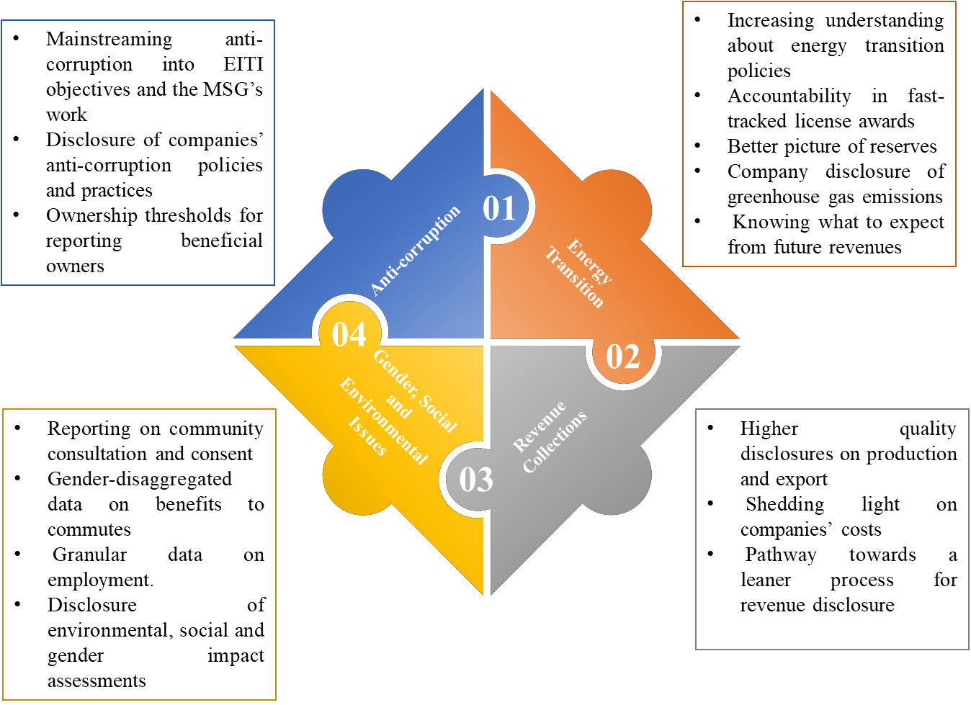
Source: EITI Standard 2023: Summary of Changes

  - Objectives of the Assignment

The assignment will be conducted leveraging the most recent 2021 NEITI reports, the Fiscal Allocation and Statutory Disbursement audit as well as the NSWG strategy for the implementation of the EITI in Nigeria detailed in the NEITI Strategic Plan for 2022 - 2026.

The report shall be in two (2) volumes titled:
    - “NEITI Oil and Gas Industry Report – 2022”
    - “NEITI Oil and Gas Industry Report – 2023”

Other resources to be leveraged are the NSWG annual work plan that reflects current government priorities-- most current is documented in section 7.2 of the 2023 – 2025 Medium Term Expenditure Framework and Fiscal Strategy Paper. The objectives and work to be undertaken by the IA are shown below.

Table 2: Objectives and Work to Be Undertaken by IA

Key Requirement | Description
Regulatory Framework and Procedures | - Report on all aspects of the regulatory framework for the oil and gas industry: including the legal framework, fiscal regime, roles of government entities and reforms, and laws and regulations relating to addressing corruption risks in the oil and gas sector.  - Provide an overview of the statutory procedures for awards and transfers of licences and assess if these procedures are followed in practice.  - Disclose comprehensive information on property rights to oil and gas licences and leases, including beneficial owner information and public accessibility of contracts and licences.  - Disclose comprehensive information about state-owned enterprise participation in the oil and gas sector.
Exploration and Production Information | - Disclose an overview of the exploration activities in the oil and gas sector highlighting its potential, recent, ongoing, and planned significant exploration activities.  - Disclose information about oil and gas production levels and a valuation of extractive output.
Export And Domestic Information | - Disclose information on oil and gas export volumes and a valuation of exports.
Revenue and Payment Management and Distribution | - Disclose all company payments and government revenues from the oil and gas sector together with associated amounts lifted (oil) or sold (natural gas) to the required level of disaggregation while adhering to approved data quality assurance procedures.

Key Requirement | Description
- Disclose the revenues ultimately transferred to the Federation Account.
- Disclose information on revenue management and distribution, highlighting subnational transfers and revenue sustainability.
- Report on the revenue flows amongst the Covered Entities and any investment by the Federation in the oil and gas industry.
- Report on balances payable/receivable at the end of the audit period for certain types of financial flows as described by the National Stakeholder’s Working Group (NSWG) contained in the Material Decision Information Memorandum.
- Reconcile the physical/financial transactions reported by payers and recipients as appropriate, as per the scope set out in the Terms of Reference alongside the NSWG Material Decision Information Memorandum.
Climate Change and Energy Transition Plan | - Provide information on government and companies' energy transition plans and policies including energy transition and climate risk considerations in revenue forecasting.  - Review and present greenhouse gas (GHG) emissions data from the oil and gas sector.  - Evaluate and present information on companies' social and environmental contributions including assessing their compliance with legal and contractual obligations to undertake social and environmental expenditures.
Contribution to Gross Domestic Product (GDP) | - Obtain, assess and include information on the contribution of the oil and gas sector to the economy.
Outcomes and Impacts | - Make observations and recommendations that will support policymaking.

See Appendix 1 Terms of Reference for further details on the objectives of the assignment.

  - Basis, Currency, and Period of the EITI Reporting

    - Basis of the EITI Reporting

The procedure for this EITI reporting is established through an agreement between the Independent Administrator (IA) and NEITI. Additionally, the IA will utilize its professional judgment and adhere to related international standards, including but not limited to ISA 530 (Audit Sampling), ISA 500 (Audit Evidence), ISRS 4400 (Engagement to Perform Agreed-Upon Procedures), and ISRS 4410 (Compilation Engagements). These standards will complement the Data Quality, Assessment, and Documentation Procedure described in this report.

    - Currency and Period of the EITI Reporting

The aggregate revenue flow in the sector for 2022 and 2023 will be stated in United States of America Dollars (US$). This will be the reporting currency for the 2022- 2023 NEITI Oil and Gas Industry Audit. However, transactions will be reported in other currencies (where those currencies were the currency of the transaction). The Central Bank of Nigeria (CBN) average exchange rates1 will be applied as shown below.

Table 3: CBN Average Exchange Rate for the 2022-2023 Oil and Gas Industry EITI Reporting

CBN Average Exchange Rate
Year | US$/ Naira | EURO/ Naira | Pounds Sterling / Naira
2023 | 645.92 | 698.86 | 809.24
2022 | 423.30 | 445.96 | 523.67

Furthermore, the average monthly rate advised by the Federation Accounts Allocation Committee (FAAC) will be used for the NNPC-related transactions and other designated cases. The report shall be in two (2) volumes titled: “NEITI Oil and Gas Industry Report – 2022” and “NEITI Oil and Gas Industry Report – 2023.” The periods to be covered in the Report are from 1st January 2022 to 31st December 2022 and 1st January 2023 to 31st December 2023.

1CBN Exchange Rate: https://www.cbn.gov.ng/rates/ExchRateByCurrency.asp

  - Scope of Work

The EITI process complements, assesses, and improves existing reporting and auditing systems. The process has six (6) conceptual phases as shown below.

Figure 2: EITI Process
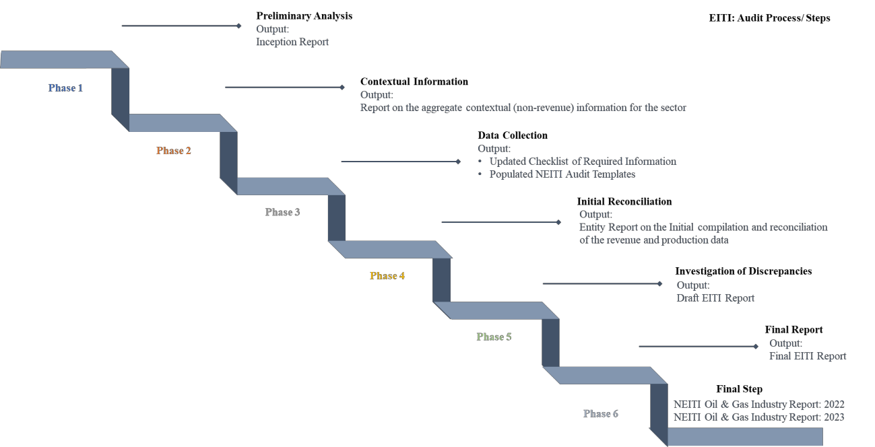

Figure 3 shows the specific approaches to be adopted to deliver the six steps highlighted above.

Figure 3: Summarised Audit Approach
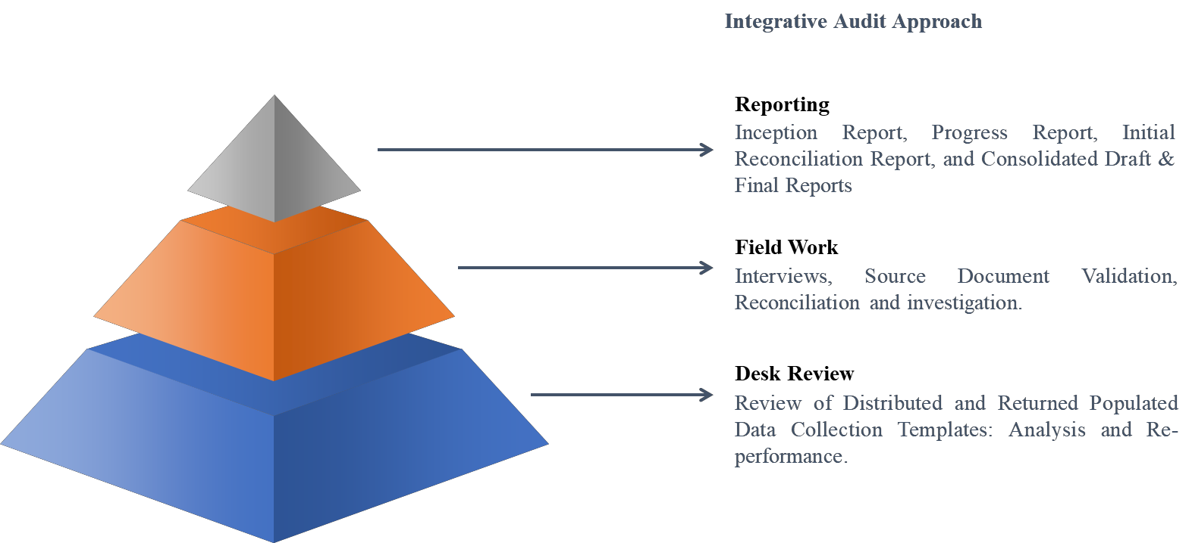

  - Overview of Covered Entities in the Current Reporting Period

The EITI Reporting Process will cover the identified stakeholders for the 2022 and 2023 NEITI Oil and Gas Upstream sub-sector value chain. The Figure below shows the production arrangement, SOEs, Collecting Agencies and Key fund managers in the Oil and Gas Industry:

Figure 4: Overview of the Key Stakeholders in the Oil and Gas Industry

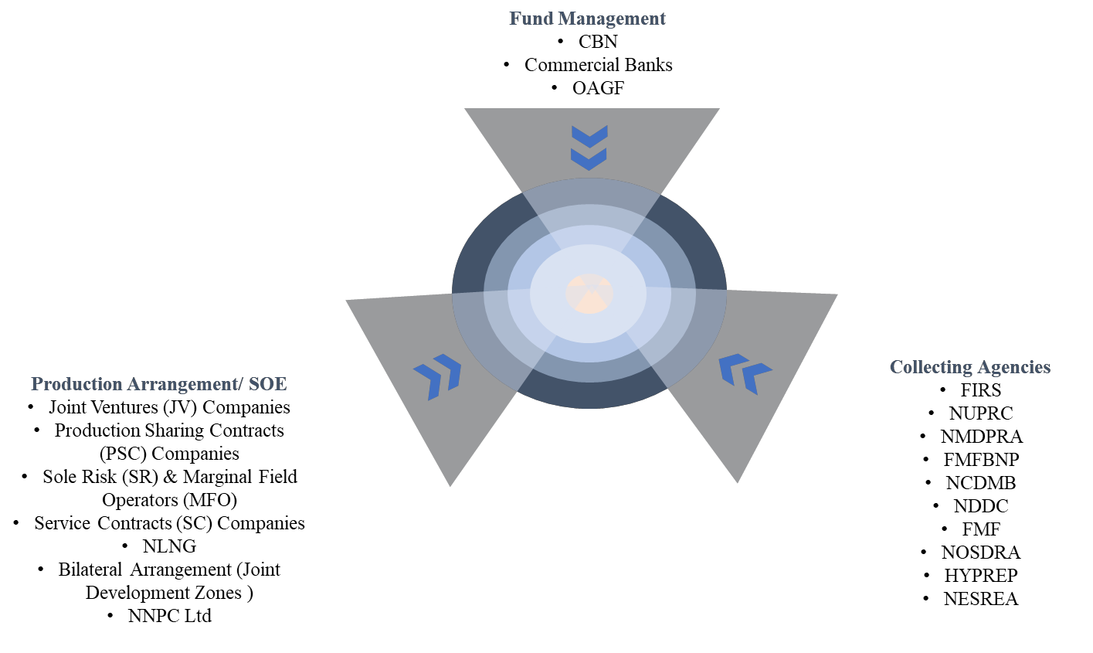

  - Timeline and Deliverables

The work plan has been structured in Six (6) phases. Below is the estimated timeline:

Figure 5: 2022-2023 OGA EITI Reporting Process Timeline

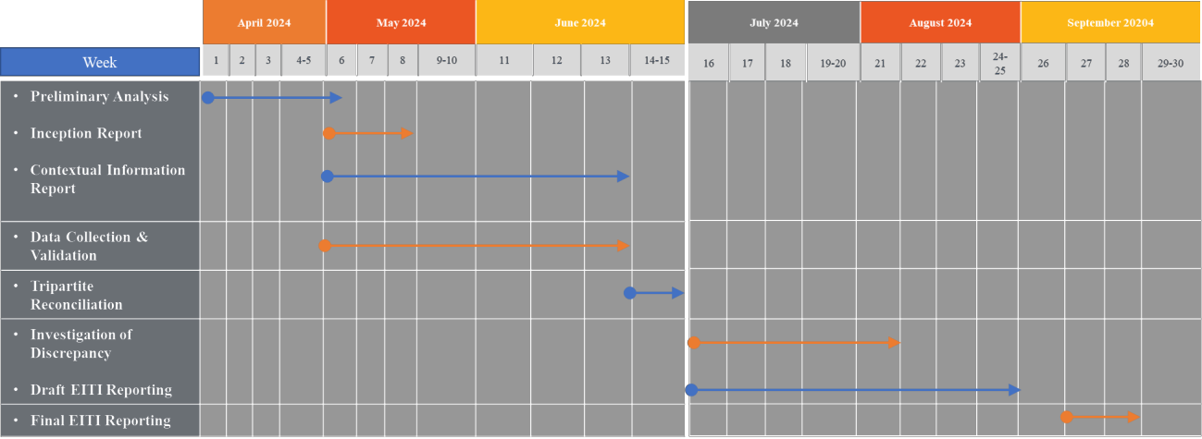

See Appendix 3 Project Implementation Schedule for further details on the timeline of the assignment. Furthermore, see Table 4 for the summarized contents of the expected Reports.

Table 4: Reporting Deliverables

S/N | Type of Report | Summarized Expected Contents
1 | Inception Report | - Statement of materiality confirming the decisions on the payments and revenues to be covered.  - Redefinition (where necessary after IA update and confirmation of NSWG definitions) of materiality and thresholds.  - Sales of the state’s share of production or other revenues collected in-kind.  - Coverage of infrastructure provisions and barter arrangements  - Coverage of transportation revenues  - Disclosure and reconciliation of payments to and from SOE.  - Material determination of and inclusion of direct sub-national payments  - Material determination of and the inclusion of sub-national transfers  - Determination of the type and level of data disaggregation for the EITI Report  - Coverage of social expenditure and environmental payments  - Coverage of quasi-fiscal expenditures  - Reconfirmation of materiality statement post IA initial assessment on NSWG’s decisions on the number of covered companies and government entities for the period including.  - Companies and the SOE that make material payments to the State.  - Government entities and any sub-national government entities that receive material payments.  - Any barriers to full government disclosure of total revenues received from each of the benefit streams agreed in the scope of the EITI report, including revenues that fall below-agreed materiality thresholds.  - Confirm what information participating companies and government entities are required to provide to assure the credibility of the data-- examination of the audit and assurance procedures which includes:  - Identifying and determining the legal and institutional requirement(s) for data quality and assurance in Nigeria  - Updating the established NSWG data quality assurance framework/mechanism for the report

S/N | Type of Report | Summarized Expected Contents
- Requesting sign-off attesting to completeness and accuracy of records.
- Requesting a confirmation letter from the company’s external auditor
- Requesting that government reporting entities obtain a certification of accuracy from their external auditor or equivalent—or state otherwise.
2 | Report on the aggregate contextual (non- revenue) information for the sector. | - Description of the legal framework and fiscal regime  - Overview of the national energy transition policies, plans and ongoing activities  - Overview of any government reforms in the oil and gas sector  - Description of the process for transferring or awarding licenses and leases  - Description of the register of licenses  - Description of the Government’s policy on disclosure of contracts and licenses  - Overview contracts and licenses that are publicly available.  - Overview of beneficial ownership disclosure  - Explanation of the role of SOE and its subsidiaries  - Overview of the SOE and its level of ownership  - Details of any loans or loan guarantees provided by the government or the SOE.  - Description of the rules and practices related to SOEs.  - Description of planned or ongoing significant exploration activities—including JDZ.  - Description of the methods for calculating production volumes and the existing monitoring mechanisms.  - Description of the sources and methods for calculating export volumes and the existing monitoring mechanisms.  - Description of government policies and practices for monitoring oil and gas project costs and managing revenue loss risks.  - Description of the budgeting and audit process of the Government  - Description of all the revenues from the sector identifying those in the national budget, subnational flows, and quasi-fiscal expenditures.  - Description of the process of revenue transfers between the national and subnational government entities.  - Overview of the assumptions underpinning forthcoming years in the budget cycle and the proportion of future fiscal revenues expected from the sector.  - Overview of the relevant legal provisions and administrative rules governing environmental impact management

S/N | Type of Report | Summarized Expected Contents
3 | - Updated Checklist of Required Information  - Populated NEITI Audit Templates | - Collect data on license and lease owners.  - Collect beneficial owner data from companies.  - Collect data on significant exploration activities,  - Collect data on proven economic reserves of oil and gas,  - Collect production data (volumes/quantities and value) for crude oil, condensate, and natural gas, disaggregated per company, project, field, region, location and product.  - Collect lifting data (volumes/quantities and value) for crude oil, condensate and sales data for natural gas and gas liquids, disaggregated per company, project, terminal, transaction, region, destination, and product.  - Collect data on greenhouse emissions,  - Collect data of payments from companies and receiving government agencies on revenues together with associated amounts of oil lifted and natural gas and gas liquids sold, disaggregated per company, project, government entity and revenue stream.  - Collect data on the sale of the state’s share of production or other revenues collectedin-kind and disaggregated into profit oil, royalties, and taxes in production sharing as well as any other arrangements whereapplicable, together with associated amounts of oil lifted and natural gas and gas liquids sold,  - Collect data on the royalties, taxes, and dividends due from the SOE in the joint venture operations, together with associated amounts of oil lifted and natural gas and gas liquids sold,  - Collect data on infrastructure and barter arrangements in line with NSWG definitions.  - Collect data on transportation and other miscellaneous revenue in line with NSWG definitions.  - Collect data on transactions related to SOE in line with NSWG definitions.  - Collect data on subnational payments in line with NSWG definitions.  - Collect data on project costs either in the form of final cost and tax audit reports or the summaries of those reports.  - Collect data on subnational transfers in line with NSWG definitions.  - Collect data on social, and environmental payments, and quasi-fiscal expenditures in line with NSWG definitions.

S/N | Type of Report | Summarized Expected Contents
- Collect employment data from public and private sectors of the oil and gas sector inabsolute terms and as a percentage of total employment disaggregated by company, gender, identifying local and foreign nationals, and occupational level. This will be disclosed along with data on the oil and gas sector's contribution to the economy.
- Collect data on additional investments undertaken by companies in the year,
- Collect all supporting documentation directly from the participating reporting entities.
4 | Entity Report on the Initial compilation and reconciliation of the revenue and production data | - Statement showing the initial, validated and discrepancies of data on production, lifting, revenue and payment reports
5 | Draft EITI Report | - Reconcile information disclosed by the reporting entities.  - Identifying any discrepancies, and other information requested by the NSWG.  - The financial data is to be disaggregated to the level of detail agreed with the NSWG.  - Describe the methodology adopted for the reconciliation of company payments andgovernment revenues and demonstrate the application of international professional standards.  - Description of all revenue streams, related materiality definitions and thresholds  - Comment on whether payments are made as at when due identifying reasons for delays if any and outstanding amounts per revenue stream asat the time of reporting.  NB: Each revenue stream should also be disaggregated and associated volumes reported in an agreed format.  - list of all companies, projects and government entities covered in the report.  - Description of the process of computing and recording all revenue streams.  - Assessment from the IA on the process adopted for the computation and recording of each revenue stream, noting any deviations from extant laws, regulations, guidelines or established processes and the limitations of the assessment provided.

S/N | Type of Report | Summarized Expected Contents
- Assessment of publicly available beneficial owner data from the CAC, NUPRC and NEITI to determine if all companies covered have the required data publicly available and identify gaps to data (if any).
- Assessment from the IA on the comprehensiveness and reliability of data presented, including an informative summary of the work performed by the IA and the limitations of the assessment provided.
- Assessment of whether all companies and government entities within theagreed scope of the report, provided the requested information, identifying any gapsor weaknesses in reporting to the IA, including naming any entities that failed to comply with the agreed procedures, and an assessment of whether this is likely to have had a material impact on the comprehensiveness of the report.
- Document whether the participating companies and government entities had their financial statements audited in the financial year(s) covered by the EITI Report, documenting any gaps or weaknesses to disclosure.

NB: Where audited financial statements are publicly available, the EITI Report informs readers on how to access this information.
6 | Final Report | - Executive Summary  - Introductions  - Overview of the Oil and Gas Sector in Nigeria  - Climate Change and Energy Transition Plan and Implementation  - PIA and Implementation: HCT, CIT substitute for PPT, Host Community Funds and 0.5% Midstream and Downstream Gas Infrastructure Fund, NNPC Frontier Exploration Fund, and Upstream Environmental Remediation Fund.  - Exploration, Production and Export  - Revenue Collection and Reconciliations  - Cash Calls  - Downstream Operations  - Social and Economic Spending  - Outcomes and Impact  - Appendices  - Working Papers

  - Approach and Methodology

The approach and methodology are designed to address the gaps identified in the 2023 Nigeria EITI Validation Assessment and to satisfy the reporting requirements of the 2023 EITI Standard.

    - Approach and Methodology: 2023 EITI Validation Gap

The IA will work closely with NEITI to provide the required input on the strategic engagement with agencies such as NUPRC and CAC for the Register of License and beneficial owner register validation. Table 5 shows the proposed action to support NEITI on the EITI Validation Scorecard.

Table 5: Proposed Action to Support NEITI on the EITI Validation Scorecard

Thematic | Requirement | Description | Proposed IA’s Action
Multi- stakeholder oversight | 1.1, 1.2, 1.3,  1.4 and 1.5 | - Multi-stakeholder oversight  - Government engagement  - Company engagement  - Civil society engagement  - MSG governance, workplan review and monitoring | - Provide suggested inputs during stakeholder engagement.
Legal and Fiscal Framework | 2.4 | Contract | - Extract detailed fiscal terms contained in signed contracts.  - Obtain an updated list of all active contracts and licenses (including annexes, amendments, and riders),  - Aggregate all legal or practical barriers if any, stating why a contract or license is not published— especially if there are legal provisions/ court injunctions/orders for non-disclosure/confidentiality.  - Where practically possible, provide references/links to all published contracts or licenses.  - Engage with NUPRC regarding ongoing efforts for contract disclosure.

Thematic | Requirement | Description | Proposed IA’s Action
Licenses | 2.2 | Contract and License allocations. | - Obtain an updated database of executed contracts and licenses allocated by the NUPRC.  - Aggregate all legal or practical barriers preventing the publication of contracts or licenses, e.g., legal or regulatory provisions/ court injunctions/orders, contract terms on non-disclosure/confidentiality.  - Assess the applicable legal and regulations governing license transfers and awards by requesting information on license awards and transfers.  - Report on identified deviations and irregularities between law and practice.  - Based on available information obtained during the audit, recommend to the NSWG amendments to existing legislation that will strengthen NUPRC’s systematic disclosure of licensing information.
 | 2.3 | Register of Licenses | - Facilitate the collection and disclosure of:  - Dates of application for licenses  - License coordinates  - Dates of expiry and precise dates (beyond the general year) of award for OPLs  - NUPRC harmonization/ mapping of all active oil and gas OPLs and OMLs, clearly indicating the coordinates of each license.  - The proposed launch of a new online  oil and gas cadastral portal in mid- 2023, as required by the PIA.  - Support NEITI’s secretariat by obtaining from the entities information to update the license register to meet EITI requirements.

Thematic | Requirement | Description | Proposed IA’s Action
Ownership | 2.5 | Beneficial Ownership | - Obtain updated information on ultimate beneficial owners of companies holding or applying for licenses/ contracts.  - Support NEITI in the mapping extracted information under two key categories: high and low risk.  - Identify politically exposed persons and ensure they are captured and disclosed in the BO registers.  - Offer pertinent insights to NEITI regarding the integration of other BO portals established by the CAC, NUPRC etc.  - Based on the review of the beneficial owners/ data, make recommendations to the NSWG thereon.
State Participation | 2.6 | State Participation | - Review the 2022/2023 audited financial statements of the NNPC and key subsidiaries to separate owned assets and Assets Under Management (AUM)—especially those managed by the NAPIMs (the investment of NNPC- currently NUIMS).  - Identify and aggregate the type, number and commercial terms of assets (licenses)/ taken over/ transferred by the government through NNPC.  - Request from NNPC all extractive subsidiaries and joint ventures in which NNPC holds majority equity interests, including those not consolidated into the NNPC group’s balance sheet.  - Ensure that NNPC Limited make full disclosure of all transactions of revenue and valuation from its subsidiaries and joint ventures.

Thematic | Requirement | Description | Proposed IA’s Action
 |  |  | - Engage and advise the NSWG on how to engage NNPC Limited for a full disclosure of all operating and capital expenditure management, procurement, subcontracting and corporate governance of its subsidiaries and joint ventures.
 | 6.2 | SOE Quasi-Fiscal Expenditures | - Obtain detailed information on all types of spending outside the national budget.  - Examine the provision of the PIA on whether certain SOE expenditures are permitted from the sales proceed crude oil and gas-- without necessarily being provided for in the national budget.  - Describe the process of making a quasi-fiscal expenditure and the supporting document thereon.
Revenue Collection | 4.3 | Infrastructure provisions and barter arrangement | - Obtain all agreements or sets of agreements involving the provision of goods and services (including loans, grants, and infrastructure works), in full or partial exchange.  - Provide a level of detail and disaggregation of key terms of the barter arrangement/ agreements, including interest rates on resource- backed loans.
 | 4.7 | Level of disaggregation | - Disaggregate oil and gas government revenues by individual project, where specific revenues are levied at a project level—those from NUPRC, NDDC, NCDMB and FIRS.  - Facilitate the identification and classification of Projects as defined in the 2022-2023 Oil and Gas ToR for engaging the IA i.e., where multiple contracts, licenses, leases, concessions, or similar legal agreements are substantially interconnected and form the basis for payment liabilities with the government.

Thematic | Requirement | Description | Proposed IA’s Action
Revenue Management | 5.1 | Distribution of Revenues | - Obtain detailed information on all types of revenues that are recorded in the national budget, by engaging with the Budget office for detail information.  - Examine the provision of the PIA that supports the recording on whether certain SOE expenditures are permitted from the sales proceed crude oil and gas-- without necessarily being provided for in the national budget.  - Describe the process of allocating oil and gas revenues derived by the government that are not included in the national budget.
Subnational contribution | 5.2 | Subnational Transfers | - Describe the process of monthly FAAC allocation.  - Obtain monthly FAAC Report to aggregate actual amount transferred to each State and the Federal Government  - Reconcile IA recomputation on transfers with government records. Government.
 | 6.1 | Social and  Environmental Expenditures | - Describe the law, regulation, or contract that mandates social expenditures by extractive companies.  - Obtain relevant contracts for material payments.  - Obtain information as well as report on all payments made by extractive companies to the government as it relates to the environment as mandated by law, regulation, or contract, where such payments are material.

    - Approach and Methodology: 2022 and 2023 EITI Reporting Process

The approach and methodology for the 2022 and 2023 EITI Reporting Process are described in the table below.

Table 6: Summary of the EITI Reporting Process and Deliverables
# | Preliminary Analysis | Contextual Information | Data Collection | Initial Reconciliation | Investigation of Discrepancies | Final Report
Key Activity | - Confirm NSWG Materiality Decisions.  - Align reporting templates (for quantitative data) and other data collection tools (for qualitative data).  - Establish data collection procedures.  - Convene a preliminary engagement with the covered entities.  - Present reporting templates.  - Communicate data  collection procedures.  - Agree on the  schedule for publishing the EITI Report. | - Aggregate contextual (non- revenue) information for the sector including Legal and institutional framework underpinning the following.  - Fiscal regime  - Contract and  license allocation.  - Revenue  collection  - Revenue  management and distribution  - Social and economic  spending. | NSWG and national secretariat to:  - Provide contact details for the reporting entities.  - Assist the IA in ensuring that all  reporting entities participate fully.  IA to:  - Follow-up  on data collection  - Obtain supporting documents. | - Compile company and project level production, payment, and revenue data  provided by the reporting entities and make preliminary analysis before validation of data submitted, | - Contact the reporting entities to clarify the causes of any significant discrepancies or other gaps in the reported data,  document as appropriate, and collect additional data from the reporting entities concerned.  - Compare and  identify any material discrepancies for further investigation in case of systematic disclosure of specific  production and financial data. | - Submit the final EITI Report to the NSWG in  twenty (20) hard copies.  - NSWG to  endorse the report before its publication and will  oversee its publication.  - Produce electronic data files that can be published together with the final Report.

# | Preliminary Analysis | Contextual Information | Data Collection | Initial Reconciliation | Investigation of Discrepancies | Final Report
 | - Review the conclusions and recommendations from the most recent NEITI Oil and Gas Industry Report and the most recent EITI Validation Assessment. | NB: Report documenting  what is publicly available through relevant Government websites, the State-Owned Enterprise (SOE) website (i.e., systematically disclosed), any other relevant credible websites with appropriate links, and through the NEITI website (i.e., EITI  Reporting). | - Advice on other mechanisms or methods to ensure that appropriate safeguards are in place to protect the integrity of the process. | - Reconcile the information disclosed by the reporting entities, identifying any discrepancies (including offsetting discrepancies) following the agreed scope and any other gaps in the information provided (e.g., assurances),  - Investigate discrepancies to a margin of 0.05% of each total revenue stream,  - Aggregate all other data for reporting in the EITI Report. | - Ensure all companies and the SOE sign off on the agreed company  positions.  - Submit draft EITI Reports to the NSWG for comment.  - Comment on the progress in implementing those measures-- Where previous EITI Reports have recommended corrective actions and reforms.  - Make recommendations for strengthening the reporting process in the future.  - Make recommendations on strengthening the ToR. | - Submit summary data from the EITI Report electronically according to the standardized reporting format available from the International Secretariat  - Populate and submit to the NSWG electronically, the Transparency Template available from the International Secretariat

# | Preliminary Analysis | Contextual Information | Data Collection | Initial Reconciliation | Investigation of Discrepancies | Final Report
 |  |  |  | - Analyze NNPC 2022/2023 financial  statements and FAAC reports especially concerning liabilities as well as any debt forgiveness by the Federation. | - Document observations of issues arising from the reporting.  NB: Make  recommendations to support policymaking and:  - Process lapses in the computation  and recording of all revenue streams.  - Assessment of Profit Oil  - Fiscal regime for gas in the PSCs | - Submit to the national secretariat all available data gathered  during reconciliation, including the contact information of all institutions contacted during the reporting process.
Output | Inception Reports | Report on the aggregate contextual (non- revenue) information for the sector. | - Updated Checklist  - Populated NEITI Audit Templates | Entity Report on the Initial  compilation and reconciliation of the revenue and production data | Draft EITI Report | Final EITI Report

  - Overview of the Oil and Gas Regulatory Framework in Nigeria

The ownership and control of all minerals, mineral oil, and natural gas in, under or upon any land in Nigeria, its territorial waters and exclusive economic zone is vested in the Government of the Federation based on the provision of Section 44(3) of the 1999 Constitution of the Federal Republic of Nigeria. The Federal Government is mandated to manage such minerals in a manner as may be prescribed by the National Assembly.

Following the enactment of the Petroleum Industry Act, 2021, the Oil and Gas industry operates with two (2) Regulators, The Nigerian Upstream petroleum Regulatory Commission (NUPRC) regulating the activities in the upstream sector and the Nigerian Midstream & Downstream Petroleum Regulatory Authority (NMDPRA). The Regulators have developed various regulations and guidelines2 to support the implementation of the PIA as described in table 7.

Table 7: Legal and Institutional Frameworks Development in the Industry

# | Title | Description / Objectives | Scope
1 | Acreage Management, Drilling and Production Regulations  Pursuant to Part II of the Petroleum Industry Act (2021) | The regulations apply to petroleum exploration  licenses, petroleum prospecting licenses and petroleum mining leases granted under the Petroleum Industry Act, 2021. | Petroleum Exploration Licences (PEL)  The regulations described the procedures and conditions for the application for the grant of a Petroleum Exploration License which shall be submitted at least 90 days before the expiration of the licence and the licensee of a PEL is expected to commence petroleum exploration operations in the licence area.  Petroleum Prospecting Licences (PPL) and Petroleum Mining are not subject to bidding rounds.  There shall be competitive bidding where more than one licensee applies for the same selected area. The Commission shall review the application within 90 days and the Minister shall within 90 days of the receipt of a recommendation by the Commission under this paragraph decide on the grant of the petroleum prospecting licence.
2 NUPRC Regulations and Guidelines for the implementation of PIA, 2021: https://www.nuprc.gov.ng/regulations-development-pia-2021/#

# | Title | Description / Objectives | Scope
Grant of a Petroleum Mining Lease on an area previously under an Oil Prospecting Licence, Oil Mining Lease or Petroleum Prospecting Licence and Petroleum Mining Lease through bidding rounds and bilateral or multilateral agreement.

Petroleum Prospecting Licence
There is a provision for optional extension for PPL with justification and payment of applicable fees.

Furthermore, a licensee shall at the expiration of the licence (whether of the initial period or the optional extension period) relinquish all areas of the petroleum prospecting licence that have not been selected as appraisal areas, commercial discovery areas, retention areas and lease areas.

Petroleum Mining Leases
PML is granted upon application, to a licensee of a Petroleum Prospecting Licence who has a field development plan approved by the Commission with respect to an area of the licence declared commercial by the licensee.

A lease may be revoked where a lessee fails to commence regular production within the development period after the completion of construction work and test commissioning provided for in the field development plan upon notification by the Commission 60 days before the revocation.

A field development plan submitted pursuant to these regulations shall include a development period proposed by the lessee pursuant to section 79(2)(n) which shall be sufficient for the construction of any required infrastructure and development of the field(s). Provided that in approving a development period, the Commission shall take into consideration any period required by any other Agency of Government to issue any approvals incidental to the implementation of the field development plan.

# | Title | Description / Objectives | Scope
2 | Frontier Exploration Fund Administration Regulations Pursuant to Section 9 of the Petroleum Industry Act, 2021. | The objective of these regulations is to provide the general rules for the administration of the Frontier Exploration Fund pursuant to section 9 of the Petroleum Industry Act (the “Act”). | Establish an escrow account called “Frontier Exploration Fund Escrow Account” (the “Escrow Account”) pursuant to section 9(4) of the Act for the purpose of managing the Frontier Exploration Fund.  The Fund is to be applied for the promotion of exploration and development of oil and gas resources in all the frontier basins of Nigeria.  NNPC Ltd is expected to make contributions of the amounts specified in Section 9(5) of the Act in the following manner:  - With respect to production sharing contracts the amounts pursuant to subparagraph  - shall be:  - 30% of the proceeds from the disposal of profit oil at the fiscal price determined by the Commission.  - 30% of the proceeds from the disposal of profit gas and the natural gas liquid derived therefrom at the fiscal price determined by the Commission.  b. The Contributions by NNPC Ltd pursuant to this paragraph shall be made quarterly.  The Commission, within six months of commencement oof the Regulation, kickstarts a Frontier basins exploration and development studies program.  - Establishing an information database of all acreages comprised in the frontier basins indicating the acreages that are licenced and the ones that are open by collecting all existing geological and geophysical data whether such data is with the National Data Repository, Nigerian Geological Survey Agency, any other governmental or private entity.  - The data base shall provide information on the analysis of all geographical, geological and geophysical data relating to both licenced and un-licenced acreages in the Frontier basins.  - Identifying all prospects and leads in both licenced and unlicenced areas of the frontier basins.  NB: NNPC Ltd can also get the Commission’s approval for the direct utilisation of the Fund.

# | Title | Description / Objectives | Scope
3 | Upstream Decommissioning and Abandonment Regulations  Under Sections 232 and 233 Petroleum Industry Act (2021). | Applicable to the decommissioning and abandonment of facilities used in upstream petroleum operations in Nigeria, including wells, all  installations and facilities associated with upstream petroleum operations under a licence or lease saved under Section  311 (9) of the Petroleum Industry Act (the Act) and Licences and  Leases granted under the Act. | A licensee or lessee of an existing upstream petroleum operation shall within one year from the coming into effect of these regulations submit to the Commission a Decommissioning and Abandonment Plan – DAP (as part of Field Development Plan) or in the case that a decommissioning and abandonment plan already exists, an updated decommissioning and abandonment plan.  DAP is expected to meet the following general and specific requirements as the case may be:  - General Requirements such as compliance with good international petroleum industry practice.  - Specific requirements in the case of offshore operations, compliance with Standards prescribed by the International Maritime Organisation on offshore petroleum installations and structures.  - Guidelines issued by the Commission pursuant to section 232 (1) of the Act.  Further consideration includes:  a. Licensee or lessee shall:  Make an application to decommission offshore installations, structures, utilities, plants, or pipelines, not involving the abandonment of wells, at least thirty-six  (36) months prior to the proposed start date of the decommissioning.  - Make an application for the decommissioning and abandonment of all or part of oil or gas fields offshore, at least forty-eight (48) months prior to the proposed start date of the decommissioning.  - Set up a Decommissioning and Abandonment Fund (the Fund) not later than three (3) months from the date of commencement of production in the case of new licences or leases, or one year from the effective date of the Regulations for existing licenses or leases of a producing field. Furthermore, notify the Commission not later than 14 days from the date of establishment of the fund.

# | Title | Description / Objectives | Scope
NB: The Fund shall be in the form of an escrow account held by a financial institution that is not an affiliate of the licence or lease holder (s). The financial institution to be a reputable commercial bank licensed by the Nigerian Central Bank and must meet a minimum credit rating of A+ or its equivalent published by either Standard & Poor 500, Fitch Ratings Inc. or Moody’s Investors Service Inc. as well as maintaining the minimum credit rating for the life of the escrow account.
- Make yearly payments of the cash amount stipulated in the DAP if the production arrangement is under a production-sharing contract, or any other contractual arrangement. Otherwise, the cash payment by the Concessionaire on behalf of the licence or lease holder (s). and if Joint Venture, the Individual parties to the JV to make yearly contributions.
NB: The amount to contribute to the Fund is subject to 10 years review or shorter depending on drastic changes in DAP fundamentals.

- Furnish the Commission a statement of accounts of the Funds not later than thirty (30) days after the end of each calendar year. A copy is also sent to the Federal Inland Revenue Service within the same timeline.

- Submit to the Commission a written report upon completion of the decommissioning and abandonment programme, stating measures for the monitoring, maintenance and management of the abandoned wells and the decommissioned site as well as any remains of installations or pipelines that may still exist.

b. The Commission shall:
- Enforce compliance with the DAP, and maintain a database of upstream petroleum installations, structures and pipelines on land and offshore Nigeria, the database shall be a public document and shall be published on the Commission’s website and subject to yearly review/ updates.

# | Title | Description / Objectives | Scope
- Invoke appropriate administrative penalties for the following:
  - Five Hundred Thousand USD ($500,000) for every year of non-compliance, payable to the Commission or revocation of the licensee’s or lessee’s interest in line with section 96 of the Act for failure to submit DAP within the time prescribed in the regulations.
  - Five Hundred Thousand USD ($500,000) for every year of non-compliance,
payable to the Commission or revocation of the licensee’s or lessee’s interest in line with section 96 of the Act for failure to establish the Fund within the time prescribed in the regulations.
  - One-year contribution to the Commission in addition to the sum due and payable to the Fund for the period or revocation of the licensee’s or lessee’s interest in line with section 96 of the Act for failure to make the yearly contribution to the Fund in the manner prescribed in the DAP.
  - One Million USD ($1,000,000) payable to the Commission for commencing DAP without the approval of the Commission.

NB: All penalties payable under these regulations may be paid in Nigerian Naira subject to the prevailing exchange rate set by the Central Bank of Nigeria (CBN) at the time of payment.
4 | Upstream Petroleum Environment Regulations 2022 | Provide guidelines to the Upstream Petroleum Environment | Project-based Environment studies Licensee/lessee and/or operator shall:  - Prepare an Environmental Risk Register (ERR) to understand and collate all risks posed by the proposed project to the people and environment and for the approval of the project. ERR complements the UEGASPIN.  - Conduct an Environmental Evaluation Study (EES) every Five (5) years from the date of commencement of operations in line with the Upstream Environmental Guidelines and Standards for the Petroleum Industry (UEGASPIN).

# | Title | Description / Objectives | Scope
- Conduct the Post Impact Assessment (PIA) following the clean-up after any incident such as oil or hazardous materials spillages, explosion/blow-out etc. has occurred, to ascertain the impact of the incident on the environment with a view to the restoration/remediation of the same and for payment of 4 compensation where applicable. The PIA shall commence not more than 1 week from the date the clean- up is certified.
- Conduct an Environmental Baseline Study (EBS) for onshore drilling of exploratory or appraisal wells of less than three (3) onshore exploratory or appraisal wells within any given 12-month duration. However, drilling three (3) or more exploratory/appraisal wells within 12 months shall require an ERR.
- Conduct an Ecological Seabed Survey (ESS) for the drilling of offshore exploratory or appraisal wells exploratory or appraisal wells less than three (3) offshore exploratory or appraisal wells within any given 12-month duration. However, drilling three (3) or more exploratory/appraisal wells within 12 months shall require an ERR.
- Institute a Biological Monitorin g of the Recip ient Mediu m for the biological evaluation of effluent toxicity based on the bioassays which shall be conducted to determine the lethal and sublethal chronic toxicity effects of their treated effluents against approved species (based on the different trophic levels) in laboratory once every 3 months. Only effluents with demonstrated low risk of lethal and sublethal toxicity action against sensitive species shall be permitted for release into the recipient body of water. Biomonitoring shall be carried out during wet and dry seasons, once every five (5) years.
- Submit for approval to the Commission an Environmental Manageme nt Plan
(EMP) in respect of all projects. Details requirements and contents of the EMP are as provided in the Upstream Environmental Guidelines and Standards for the Petroleum Industry in Nigeria (UEGASPIN).

# | Title | Description / Objectives | Scope
Upstream Oil Field Waste Managem ent
Oil Field Wastes shall not be discharged into the environment without the written approval of the CCE. Where required, such wastes shall be transported in fit-for-purpose containers/vessels as determined by the Commission.

A licensee/lessee and/or operator shall:
- Prohibited from carrying out operational discharges of Produced Formation Water (PFW) from upstream oil and gas facilities and installations into the zero-discharge zone without written approval from the Commission with the following disposal options:
  - Injection into approved disposal well(s)
  - Re-injection into approved reservoir(s)
  - Other option(s) approved by the Commission.
- Not discharge whole drilling mud or fluids, spent drilling mud or fluids, brine, drill cuttings, well treatment wastes, deck drainage or residues thereof, from water and oil or synthetic-based muds from drilling activities without the written approval of the Commission Chief Executive directly or indirectly into:
  - Land, any inland waters or public drains and sewer.
  - Swamp, Coastal, nearshore waters and offshore zero discharge zone
  - Any pit on land/swamp other than an approved temporary retention pit and/or steel tanks so designed and utilized that there shall be no overflow, leakage or seepage into the environment.

# | Title | Description / Objectives | Scope
Emergency R esponse and Pollu tion Abatement
An Operator shall:
- submit its current Oil Spill Contingency Plan (OSCP ) document to the Commission within the first quarter of the year for review. The OSCP shall be activated annually.
- Be responsible for the containment and recovery of any myst ery spill discovered within its operational area, whether or not its source is known. The operator shall take prompt and adequate steps to contain, remove and dispose of the spill.

NB: All spills of crude oil, chemical, and oil products shall be reported to the Commission within 24 hours, in accordance with the Oil Spillage and Notification
Reporting forma t prescribed by the Commission.

Climate Chan ge
- There shall be mandatory monitoring, estimation of volume and reporting of Green
Hou se Gases (GHG) emission s from all oil and gas operations in the Nigerian Upstream Petroleum Industry. The Commission Chief Executive shall issue a Guideline for GHG inventory reporting and mitigation in line with international best practices.

The licensee or operator shall:
- Conduct monitorin g and control of me thane e mission s from new and existing facilities or projects in which the following activities are performed:
  - The exploration and extraction of hydrocarbons
  - The treatment refining and storage of the extracted hydrocarbon
- Take inventory of equipment and components, identify sources and possible sources of methane emissions and thereafter perform the Leak Detec tion and Repair
(LDAR) programme in all the new and existing facilities as part of methane emission management.

# | Title | Description / Objectives | Scope
- Develop and submit a plan for decarbonization and net-zero targets in operations to the Commission.

Statutory Reporting
- The licensee, lessee or operator shall period icall y submit applicable reports in line with statutory provisions, Guidelines and requirements.

Laboratory Op erations in the Upstream Petrole um Industry
All laboratories (operator-owned in-house and third-party laboratories) in the upstream petroleum industry shall be subjected to accreditation by the Commission.

Oil Field Chemical Cer tification
All oilfield chemicals and products intended for use in the Nigerian upstream petroleum Industry shall be screened to ascertain their hazard and risk potentials through Safety Data Sheet evaluation, relevant tests and any relevant investigation as may be prescribed by the Commission.
5 | Upstream Environmental Remediation Fund Regulations | Applies to the environmental remediation fund required under section 103 of the Petroleum Industry Act, 2021. | - The Fund is a special account under [relevant finance management act] established for the Commission.  - The fund shall be funded by the financial contributions for remediation of environmental damage levied on licensees of petroleum prospecting licenses and lessees under section 103 of the Petroleum Industry Act, 2021 and under the Regulations.  - The main purpose of the Fund is to provide a source of funding for the rehabilitation or management of negative environmental impacts from petroleum operations, which shall include upstream petroleum operations and petroleum operations that meet the condition of section 8(g) of the Petroleum Industry Act, 2021.

# | Title | Description / Objectives | Scope
- The financial contribution shall be paid each year with respect to each petroleum prospecting licence or lease, including for the year in which a petroleum prospecting licence or a lease has been granted.
- The initial financial contribution shall be paid by the prospective licensee or lessee prior to the granting of the licence or lease and shall apply to the first year in which a licence or a lease is granted.
- The licensee or lessee shall:
  - Submit the calculation of the annual financial contribution in the form prescribed by the Commission not later than thirty days (30) days after the payment due date and where actual capital expenditures or actual production or both are different from the estimated expenditures or production or both the required adjustment shall be made.
  - Subject the Fund to audit, following guidelines that the Commission may issue.
6 | Upstream Petroleum Safety Regulations 2022 | It provides guidelines on the duties of  companies, managers and employees. As well as the diving operations | Duties of Companies  Appoint a manager, and provide Personal Protective Equipment, Fire fighting and first aid equipment. Furthermore, provides procedures and guidelines, plans for emergencies, and conducts safety studies, amongst others.  Duties of Managers  Ensure compliance with Regulations and Safety of People, processes, Operations and Equipment. Furthermore, conforms to good Oil and Gas Field Practice.

# | Title | Description / Objectives | Scope
7 | Domestic Gas Delivery Regulations 2022  Made on the 18th day of November 2022.  Gazette No 206 dated 23rd November 2022 | To determine, regulate and enforce the domestic gas delivery  obligations. Also, to establish the criteria for allocation of domestic gas delivery obligations and to determine the pricing mechanism for utilised gas delivery obligation to the domestic market. | Determination and Allocation of Domestic Gas Delivery Obligations  - A lessee shall, prior to the 1st of February of each year, disclose information relating to its natural gas reserves and resources, as of December 31st of the preceding year, based on the classification indicated in the Schedule to the Regulations.  - A lessee shall:  Use the prices as applicable to the average of its first-day sales of each month from January 1st to December 31st of the preceding year.in determining proved developed producing reserves,  - Ascertain the commercial value of the natural gas at the measurement point on the basis of the total revenue expected to be generated in determining proved developed non-producing reserves and proved undeveloped reserves for domestic gas demand requirement for the strategic sectors, using the following:  - The price of raw gas that the lessee is expected to obtain, where they receive  an aggregate natural gas price as estimated, and the value of the possible natural gas liquid content in the raw gas.  - Price for natural gas liquid, where it is produced separately.  - Price for condensate as projected to be received.  - Incur a penalty of US$3.50 per MMBtu of gas not delivered for failure to comply with the domestic gas delivery obligations under the Act and the Regulations.  - Commission shall:  - Upon receipt of the domestic gas demand requirement supply curve from lessees, aggregate the curves to a national supply curve.

# | Title | Description / Objectives | Scope
- Identify on the supply curve the lowest level for the domestic gas supply price for which the total domestic gas demand requirement for the power, commercial and gas-based industrial sectors, shall be supplied, taking into account the production profiles of the proved developed producing reserves and the profiles in regulation 4(10) of these Regulations relating to domestic gas supply price, the established domestic gas supply price shall be provided to Authority for its base price determination.
- Order the allocation of the domestic gas delivery obligation in the sequence of the applicable proved reserves ranking from the lowest to the highest domestic base price capped by the domestic gas supply price.
- Use an allocation formula that incorporates an efficiency factor, reserves, and flaring volume to determine the allocation to a lessee, having regards to the efficiency factor which essentially accounts for constraints related to availability and proximity to major transport trunk lines, including Oniafy-Obrikom-Oben (OB3) gas pipeline, Ajaokuta-Kaduna-Kano (AKK) gas pipeline and Escravos-
Lagos Pipeline System (ELPS).
8 | Petroleum Licensing Round Regulations 2022 | To provide a seamless procedure and regulatory framework for conducting a fair, transparent and competitive bidding process for the grant of petroleum prospecting licence and petroleum mining lease | Grant of Licence or Lease to winning Bidder  A Petroleum Prospecting Licence or a Petroleum Mining Lease shall only be granted to the winning bidder based on a bidding process.  Development and publication of a licensing round plan  - Licensing Round Plan to be published on the Commission Website—plan to include government policies in the long-term management of petroleum resources indicating the reserve targets, gas utilization objectives, indigenous participation, and development of carbon capture infrastructure.  - The duration of a licensing round shall be sufficient for bid participants to evaluate all geological, geophysical, technical, economic, and fiscal conditions relating to a block, but shall not be more than 365 calendar days.

# | Title | Description / Objectives | Scope
- The commission may determine:
  - Minimum signature bonus to be paid into the Federation Account in line with section 258(2) of the Act.
  - Minimum additional royalty acceptable under a bid proposal and maximum additional royalty under the bid proposal.
  - Minimum additional per centum acceptable under a bid proposal and maximum
additional per centum under the bid proposal.

NB: A profit split or profit oil split shall be an additional percentage profit oil or profit oil split applicable to the entire sliding scale in the respective model contract and the additional profit split or profit oil split to the Government may be a per cent with up to three decimals.
9 | Petroleum Royalty Regulations 2022 | To establish the procedure for the determination of royalty payable and administration of the royalty regime as provided under the Act | Royalty on Oil Prospecting Licences and Oil Mining Leases  Holders of oil mining leases or oil prospecting licences shall continue to pay royalties under the Petroleum Act, 1969 and Deep Offshore and Inland Basin Production Sharing Contact Act until converted or renewed under the Act or any regulations made pursuant to the Act.  Payment of Royalty  Production of Petroleum, including production tests, shall be subject to royalties pursuant to section 306 of the Act and the Regulations.  Royalties shall be:  - Levied on a non-discriminatory basis with respect to all Petroleum Prospecting Licences (PPLs) and Petroleum Mining Leases (PMLs).  - Paid into the Federation Account and verified by the Commission.

# | Title | Description / Objectives | Scope
NB: where:
- two or more entities are holders of a PPL or PML, each participating entity shall pay the royalties on its participating interest.
- an incorporated joint venture is created, the incorporated entity shall pay the royalties on behalf of all shareholders.

Production is subject to royalty
The production subject to royalty from a field shall consist of the following:
- For crude oil, the chargeable volume of crude oil
- For natural gas, the chargeable volume of natural gas, including any natural gas liquids contained in the raw gas produced in the field.
- For condensates, the chargeable volume of condensates
- For natural gas liquids produced separately in the field; the chargeable volume of natural gas liquids.

NB: Where the production of a field is derived from more than one PML derived from different PPLs, and the field extends beyond the boundaries of the PMLs, the production of the field for royalty purposes shall be based on the sum of the productions determined in all PMLs for such field.

Furthermore, where a field extends beyond the boundaries of different PPLs and more than one PML is derived from the PPLs, the determination of royalty shall be based on the sum of the production from the PMLs covering such field.

Chargeable volumes shall:
- be determined at standard temperatures and pressures as may be prescribed from time to time by the Commission.
- be measured with petroleum measurement meters located at the measurement point unless approved otherwise by the Commission pursuant to the Regulations.

# | Title | Description / Objectives | Scope
- pursuant to the outcome of an audit, include production that is lost prior to the measurement point because of:
  - Unauthorized flaring.
  - Production practices are contrary to good international petroleum industry practices.
  - Gross negligence or willful misconduct of the licensee or lessee.

NB: Crude oil, condensates and separately produced natural gas liquids shall be measured in barrels.

Natural gas shall be measured in standard cubic feet and MMBtu, and where so justified, the Commission may approve reporting of production of natural gas liquids in metric tons.

Production subject to royalty shall be determined monthly and be reported.

Petroleum Measurement Meters
Subject to regulation 8 of these Regulations, a lessee shall not engage in the production of petroleum from a PML without the installation of petroleum measurement meters approved by the Commission.

Where production capacity in a PML exceeds the capacity of the petroleum measurement meters, the lessee shall upgrade the capacity of such meters or install new meters of appropriate capacity, and where meters of the appropriate capacity have not been installed the lessee shall not produce petroleum in excess of the capacity of the installed meters.

# | Title | Description / Objectives | Scope
The lessee shall measure the following through separate petroleum measurement meters:
- Crude oil, whether or not spiked with condensates.
- Natural gas, including the natural gas liquids in the raw gas from the field.
- Condensates, where condensate is produced as a separate stream from crude oil.
- Natural gas liquids, where natural gas liquids are produced as a separate stream from natural gas.

Commission:
- Prescribe the specifications of petroleum measurement meters.
- May approve more than one petroleum measurement meter for crude oil, condensates, natural gas or natural gas liquids subject to production conditions in a PML and provided that for royalty purposes, the production for each stream shall be the total production from all petroleum measurement meters for such stream.
- May approve other points of measurement of petroleum, where it is not practicable or economical to establish petroleum measurement meters at the measurement point in a PML.
- Conditions under which the Commission may approve other points of measurement of petroleum include:
  - PML is entirely carried out by subsea production installations connected to production facilities in another PML.
  - PML based on a unitization agreement is produced partly or completely through wells in another PML.
  - Individual well in a PML is directly connected with gathering lines to the production facilities in another PML.

# | Title | Description / Objectives | Scope
Furthermore:
- Where petroleum is being produced from more than one PML derived from the same PPL, the chargeable volumes shall be determined separately for each PML.
- Unless otherwise approved by the Commission, a licence or lease may be revoked for failure to install an approved meter and production of petroleum without being measured with such meter.
- A person who produces petroleum in excess of the capacity of an approved meter is liable to:
  - An administrative penalty of US $ 100,000 in the first instance and US $5,000 for each day production continues.
  - Revocation of licence or lease where such default continues for one year after the date of imposition of the US$100,000 penalty by the Commission.

Application of royalties based on price.
- The price benchmark for royalty by price shall be as specified in the Schedule to the Regulations.
- The royalty by price shall be based on the fiscal oil price for crude oil or for condensates.
- Pursuant to paragraph 11(1) of the Seventh Schedule to the Act, a royalty-by-price rate shall apply as follows —
- for fiscal oil price less than or equal to the benchmark price pursuant to paragraph 11(1)(a) of the Seventh Schedule to the Act, the royalty by price rate shall be 0%.
- for fiscal oil price between the benchmark prices pursuant to paragraph 11(1)(a) and (c) of the Seventh Schedule to the Act shall be based on linear interpolation
- for fiscal oil price greater than or equal to the benchmark price pursuant to paragraph 11(1)(c) of the Seventh Schedule to the Act, the royalty by price rate shall be 10%.

# | Title | Description / Objectives | Scope
Determination of Royalty for Natural Gas utilized in-country.
The following procedure shall apply in relation to royalty for marketable natural gas in- country:
- The applicable rate shall be 2.5% pursuant to paragraph 10(6) of the Seventh Schedule to the Act.
- The rate referred to in paragraph (a) shall apply to marketable natural gas produced and utilized in-country, where the lessee provides information to the Commission on:
  - The volume of gas delivered in-country.
  - The volume of gas was destined for export.
  - Destination certificates are based on the related purchase and sales agreements or other relevant information.
  - Respective destination certificates where the lessee sells natural gas to a supplier or wholesale customer.

Valuation for Royalty Purpose
Crude oil, Natural gas, Natural Gas liquids and Condensates for royalty purposes shall be based on the fiscal price determined at the measurement point.

Monthly determination
The commission shall determine the fiscal oil prices applicable to crude oil, condensates, natural gas and natural gas liquids at the measurement points for each PML during the first 10 days following the month in which production took place from such PML, based on information available during such month in accordance with the Regulations.

# | Title | Description / Objectives | Scope
Royalty statements and assessments.
- A lessee shall file with the Commission a royalty statement for the PML for each month, starting from the month in which regular production commences and ending the month in which production ceases permanently for the PML.

- The royalty statement shall be filed on or before the 15th of each month following the month of production and where all or part of the royalty is paid in cash such royalty statement shall be accompanied by the evidence of payment and the receipts obtained from the Commission.

A royalty statement shall contain:
- The following information about the previous month:
  - the respective total volumes of crude oil, condensates, natural gas and natural gas liquids produced and where different types of petroleum are being produced the total volumes of each type.
  - the fiscal prices for crude oil, condensates, natural gas and separately produced natural gas liquids.
  - The royalty percentage is determined for crude oil, condensates, natural gas liquids and natural gas.
  - the calculation of the royalty and payment of royalty in kind and in cash for crude oil, condensates, natural gas liquids and natural gas.
  - such other information as may be required from time to time by the Commission.

- Certificate by an officer or other person employed by the lessee who has the requisite authority to make the certificate, stating that the person signing the certificate has examined the royalty statement, including accompanying schedules and statements, and that the information given in the royalty statement is, to the best of the knowledge of such person, correct and complete.

# | Title | Description / Objectives | Scope
Estimates
- A lessee shall provide to the Commission:
  - Estimates of the amount of the royalty payable for crude oil, condensates, natural gas liquids and natural gas for the following 12 months on or before the 31st of December of the preceding year, which shall be updated quarterly.
  - Estimated lifting schedule for crude oil, condensates, natural gas liquids and natural gas for the following 12 months prior to the 15th day of each month on a continuous basis.
  - Estimates of the amount of royalty payable for crude oil, condensates, natural gas liquids and natural gas prior to the 28th day of February on a calendar year basis for a rolling five years following the year in which production occurs.
- Commission:
  - May require revised estimates for one or more months or calendar years for which estimates have been prepared by the lessee where the Commission believes that the estimates made may be materially inaccurate and in this case,
the Commission shall provide the lessee with the reasons why the Commission believes estimates may be inaccurate.
  - Shall keep a record of the information always updated in a shared database with relevant government agencies.
Audit
A lessee or licensee shall, for the purpose of an audit or examination by any authorized person, make available at all reasonable times the following:
- Books, records, accounts, documents and other information.
- Copies of any contracts that have been entered into or amended during the period.
- Copies of any joint operating agreement or agreements between the operator, lessee and other parties.
- Reasonable assistance and access to all relevant sites and answer orally or in writing, all questions.

# | Title | Description / Objectives | Scope
10 | Production Curtailment and Domestic Crude Oil Supply Regulations, 2023  Made on the 24th  day of May 2023.  Gazette No 128, Lagos 17th July, 2023. | To provide the general rules for production curtailment and utilisation of the produced petroleum in relation to export and domestic crude oil supply  obligation pursuant to sections 8(C) and 109 of the Act | Crude Oil Production and Allocation  - Regular production of petroleum from a Well shall be based on the Technical Allowable Rate (TAR) and production quota issued by the Commission.  - TAR is based on the report of the Maximum Efficiency Rate (MER) test conducted by a lessee and submitted to the Commission.  - The Commission allocates TAR for regular production from a Well for a duration not exceeding six months cycle as January to June of every year and July to December of every year.  - Lessee shall not produce petroleum from a Well in a lease area above the production quota assigned by the Commission.  - An administrative penalty of US$5, 000 for every day the contravention subsists for failure to notify the Commission within 48 hours on the utilised/ underutilizing allocated production quota for seven consecutive days.  Domestic Crude Oil Supply Obligation (DCSO) and Export Control  - Crude oil produced by a Lessee is subject to DCSO imposed by the Commission, provided entitlement to export any volume more than its DCSO.  - The commission shall curtail the Lessee’s export of crude oil through:  - Processing and endorsement of Export Permit issued by the FGN.  - Ensuring Export volume is within the production quota allocated by the Commission considering the imposed DCSO.  - Ensuring export doesn’t violate DCSO.  - The commission shall publish on the official website on a six-month basis and in three national newspapers the domestic crude refining requirements of operating refineries in Nigeria.  - Commission shall upon receipt of information of shortage or inadequate supply conditions to operating refineries in Nigeria from the Authority, issue an RFQ to all producing licenses and lessees to submit quotations to meet the supply shortage conditions.

# | Title | Description / Objectives | Scope
- Conditions for imposing Supply Obligation is by identifying and selecting producing licenses and lessees based on:
  - Proximity and accessibility of the supply location to the refiner’s location.
  - Matching of the licensee's or lessees’ crude specification to the grade requirements for domestic supply.

Furthermore, conditions to imposed DCSO is by allocating volumes based on the weighted proportion of total production of Licensees or lessees in consideration of:
  - Any existing refinery supply contracts.
  - Any existing crude export contract.
  - TAR and production quota per Lessee.

NB: Contract to sale between the DCSO Lessee and the Refinery may be based on Payment Guarantees (PG). Payment shall be in US dollars or Naria as may be agreed between parties. Where production is below the allocated quota for a quarter, Lessee shall first fulfil DCSO before considering export. However, export may be considered where there is no demand by any refinery license holder in that quarter.

A Lessee submits a monthly report on:
  - Production performance is based on the allocated quota.
  - Utilisation of production in terms of DCSO and export.

Administrative penalty to be imposed for failure to:
- Respond to an RFQ: US$10,000
- Enter into/deliver under DCSO contract: 15% of the fiscal price of the DCSO volume.

# | Title | Description / Objectives | Scope
11 | Gas Flaring and Venting (Prevention of  Waste and Pollutions) Regulations, 2022 | To protect the environment | Notice to relaunch of Nigerian Gas Flare Commercialization Programme was issued in September 2022. The Flare Gas (Prevention of Waste and Pollution) Regulations, 2018: with gazette No 88 dated 9th July 2018. The objective is for the protection of the environment, prevention of waste of natural resources and creation of social and economic benefits from gas flare capture.  Timeline of relaunch:  - Status Validation/Registration of Interest/RFQ: 30th September - 28th October 2022  - Statement of Quotation (SOQ) Evaluation/Notification of Qualified Applicants: 31st October - 4th November 2022  - Request for Proposal (RFP) stage: 7th November – 18th December 2022  - RFP Evaluation: 19th December - 23rd December 2022  - Announcement of Preferred Bidders: 28th December 2022  - Award Ceremony: 30th December 2022
12 | Nigerian Upstream Petroleum Advance Cargo Regulations, 2022 | To ensure seamless cargo operation in the upstream petroleum. | To establish a regime for advance cargo declaration of petroleum exported from the shores of Nigeria and to identify and establish a database of petroleum exports from Nigeria. Furthermore, to eradicate crude oil theft, illegal topping at crude oil export terminals and under-declaration of petroleum exported from Nigeria.  The Regulations shall apply to:  - Licensees and lessees conducting upstream petroleum operations, including all activities in connection with the exportation of petroleum from Nigeria through channels such as terminals and ports, whether such channels are onshore or offshore.  - Any terminal and port operator or other third party who is engaged or involved in the export of petroleum from Nigeria on its behalf.

Other ongoing developed regulations and guidelines are shown in Table 8.

Table 8: Other Development under consideration

# | Title
1 | Draft Amendment Sections to the Nigerian Upstream Petroleum Host Communities Development Regulations
2 | Draft Nigerian Upstream Commercial Regulations
3 | Draft Nigeran Upstream Petroleum Assignment of Interest Regulations
4 | Draft Nigeran Upstream Petroleum Development Contracts Administration Regulations
5 | Draft Nigerian Upstream Petroleum Sector Code of Conduct Regulations
6 | Draft Nigerian Upstream Petroleum Administration Harmonization Regulations
7 | Draft Nigerian Upstream Revocation of Licenses and Leases Regulations

  - Independent Administrator’s (IA) Assessment of the NSWG Material Decision
  - IA Comments on the Materiality Decision

The IA has reviewed the NSWG materiality decision and herewith confirms its adequacy for the reconciliation project.

Additionally, the IA proposes to consider the revenue streams generated from the sector, which are expected to arise as a result of the implementation of the Finance Act 2022 and the Petroleum Industry Act 2021:

    - Stamp Duties collected in the sector from the companies.
    - Decommissioning and Abandonment Fund under the administration of the NUPRC
    - Host Community Development Trust Fund
    - 0.5% Midstream and Downstream Gas Infrastructure Fund
    - Frontier Exploration Fund
    - Upstream Environmental Remediation Fund

See Appendix 2: NEITI NSWG Materiality Decisions for further details.

3.0. Data Quality, Assessment, and Confidentiality
  - Basis of Data Quality, Assessment and Confidentiality

The IA team will adopt a data quality assessment methodology that ensures the transparency and accountability of the Reporting process. The strategy for data quality is shown in Figure 6.

Figure 6: Data Quality Lifecycle

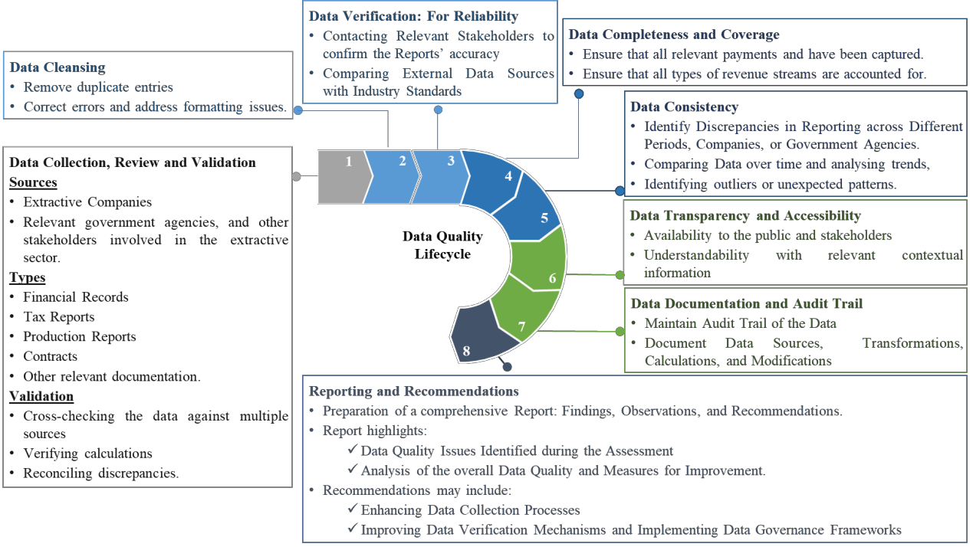
  - Comment on the Assessment Procedure and Documentation for Data Quality

In addition to the Data Quality, Assessment and Confidentiality procedures, the IA intends to align the same with the relevant international standards on auditing as well as standards set by the Financial Reporting Council of Nigeria on the adoption of international financial reporting standards as well as the International public sector accounting standards championed by the Office of the Accountant-General of the Federation.

The IA is confident that the foregoing procedures will ensure the quality and completeness of data for the 2022 – 2023 NEITI Oil and Gas Industry Report.

  - Comment on Data Collection Templates, Tools and Strategies

The IA team expects to review the data collection templates, tools and strategy in light of the new requirement in the 2023 EITI Standard.

The key expectations on the data collection templates, tools and strategies are:

- Insertion of columns on OML/PML and Field name in all the templates to meet the requirement on project level/ asset-based reporting
- Modification of employment data template to include pay range.
- Developing a revised audit information request checklist with emphasis on systematic disclosure and obtaining documents that describe processes and procedures.
- Facilitating workshops and training sessions for covered entities on the new EITI requirement.
- Scheduling sub-sessions with the government entities to reinforce expectations considering new developments in the 2023 EITI Standard.
- Giving and obtaining spot clarification to/from covered entities through emails and telephone calls.
- Ensuring that audit collection templates and validation documents are provided in line with checklists.

4.0. Preliminary Activities and Audit Planning
  - Discussion on Work Done
The preliminary activities and audit planning are as follows:
- Carried out desk review of systematically disclosed information obtained from the NUPRC, NBS, NNPC Ltd, and the OAGF.
- Developed the Project Implementation Schedule
- Reviewed the Audit Data Collection Templates and Checklist
- Held the pre-engagement meetings on Friday 12th of April 2024. Table 9 shows the agenda.

Table 9: Pre-Engagement Meetings Agenda

Programme | Responsible Person | Time
Registration/Introductions | All | 10.00-10.10 am
Welcome/Opening Remarks | Director of Energy & Mining | 10:10 – 10:20 am
Remarks from the Executive Secretary | Executive Secretary | 10:20 – 10.40 am
- Project Implementation Schedule  - Brief by Adeshile Adedeji &Co on their perspective of the project's ToR and understanding of the 2023 EITI Standard.  - Inception report (Contents and structure)  - Report Structure (Contextual information, Main and Appendices, open files – Excel, CSV etc.)  - IA Teams composition for the audit.  - IA Template Review and Update | Adeshile Adedeji & Co | 10:40 –11:50 am
Break | ALL | 11:50-12:00 pm
2022-2023 Oil and Gas Audit  - 2023 EITI Standard/Emerging issues  - Template Workshop  - Sending of Template, ToR & confidentiality agreement, template workshop with covered entities.  - Contact persons in the teams. Emails to have all team members in copy. | Team Lead, Energy & Mining | 12:00 -12:50 pm
Lunch Break | ALL | 12.50-1.30 pm
Question and Answers | ALL | 1.30-2.30 pm
Feedback on the Engagement from Adeshile Adedeji &Co | Adeshile Adedeji & Co | 2.30 pm- 3.00 pm
AOB | ALL | 3.00 pm- 3.20 pm
Closing Remarks | DD & Head Remediation | 3.30 pm

See Appendix 7: Pre-Engagement Meeting Presentation on the Overview of the Audit Approach and Methodology.

  - Initial Observation and Expectations
4.2.1 Crude Oil Production

536.75 million barrels was the total production in 2023 which was 7% higher than 2022 production data of 502.99 million barrels recorded in 20223. Figure 8 shows the graphical presentation on an aggregate basis irrespective of the OPEC Classification while Table 10 shows the disaggregation into Crude oil, blended condensate, and unblended condensate.

Figure 7: Aggregate Production Data – Million Barrels
60.00

50.00

40.00

30.00

20.00

10.00

-
Februar
Septem
Novemb Decemb

January |  | y | March | April | May | June | July | August | ber | October | er | er
2023 | 46.87 | 43.45 | 47.57 | 37.56 | 44.33 | 44.98 | 40.41 | 43.85 | 47.17 | 48.42 | 43.99 | 48.14
2022 | 51.98 | 42.66 | 46.33 | 44.47 | 39.65 | 42.10 | 40.74 | 36.57 | 34.12 | 38.14 | 42.42 | 43.82

Table 10: Disaggregated Production Data- Million Barrels

Crude Oil  Mbbl |  | 2023  Blended Unblended Condensate Condensate  Mbbl Mbbl |  | Total  Mbbl | Crude Oil  Mbbl | 2022  Blended Unblended Condensate Condensate  Mbbl Mbbl |  | Total  Mbbl | Changes  Mbbl %
January | 39.27 | 1.80 | 5.81 | 46.87 | 43.35 | 2.15 | 6.47 | 51.98 | (5.11) | -10%
February | 36.18 | 1.96 | 5.31 | 43.45 | 35.22 | 2.08 | 5.36 | 42.66 | 0.79 | 2%
March | 39.27 | 2.56 | 5.75 | 47.57 | 38.36 | 1.94 | 6.03 | 46.33 | 1.24 | 3%
April | 30.13 | 2.03 | 5.40 | 37.56 | 36.58 | 1.90 | 5.99 | 44.47 | (6.91) | -16%
May | 36.87 | 1.95 | 5.52 | 44.33 | 31.76 | 1.82 | 6.08 | 39.65 | 4.68 | 12%
June | 37.83 | 1.89 | 5.27 | 44.98 | 34.75 | 1.40 | 5.95 | 42.10 | 2.88 | 7%
July | 33.76 | 1.26 | 5.39 | 40.41 | 33.60 | 1.05 | 6.09 | 40.74 | (0.33) | -1%
August | 36.62 | 1.53 | 5.71 | 43.85 | 30.14 | 0.78 | 5.64 | 36.57 | 7.29 | 20%
September | 40.40 | 1.52 | 5.25 | 47.17 | 28.13 | 0.47 | 5.51 | 34.12 | 13.05 | 38%

3 NUPRC Production Data: https://www.nuprc.gov.ng/oil-production-status-report/

Crude Oil  Mbbl |  | 2023  Blended Unblended Condensate Condensate  Mbbl Mbbl |  | Total  Mbbl | Crude Oil  Mbbl | 2022  Blended Unblended Condensate Condensate  Mbbl Mbbl |  | Total  Mbbl | Changes  Mbbl %
October | 41.87 | 1.50 | 5.05 | 48.42 | 31.45 | 0.88 | 5.82 | 38.14 | 10.28 | 27%
November | 37.51 | 1.48 | 4.99 | 43.99 | 35.57 | 1.22 | 5.63 | 42.42 | 1.56 | 4%
December | 41.39 | 1.65 | 5.10 | 48.14 | 38.29 | 1.49 | 4.04 | 43.82 | 4.32 | 10%
Total | 451.09 | 21.11 | 64.56 | 536.75 | 417.21 | 17.16 | 68.62 | 502.99 | 33.76 | 7%

See Appendix 4: NUPRC Production Data: 2022 and 2023 for further details on production data on a crude type basis and company basis.

IA Expectations
The IA expects to reconcile the NUPRC record of production data with the Companies and NNPC.

4.2.2 Product Importation and Local Production

23.54 billion litres of PMS were imported4 from January to December 2022 while 14.48 billion litres were imported from January to August 2023 as shown in table 11.

Table 11: Products Supplied: Importation

 | 2022 |  | 2023
 | PMS | AGO | PMS | AGO
 | Billion Litres | Billion Litres | Billion Litres | Billion Litres
January | 1.84 | 0.23 | 2.09 | 0.41
February | 1.42 | 0.29 | 1.99 | 0.48
March | 2.53 | 0.24 | 2.29 | 0.56
April | 2.31 | 0.31 | 1.91 | 0.39
May | 1.97 | 0.37 | 2.01 | 0.46
June | 1.50 | 0.45 | 1.64 | 0.53
July | 1.95 | 0.39 | 1.45 | 0.24
August | 2.23 | 0.32 | 1.09 | 0.15
September | 1.80 | 0.16 | - | -
October | 1.76 | 0.42 | - | -
November | 1.97 | 0.34 | - | -
December | 2.27 | 0.47 | - | -
Total | 23.54 | 4.00 | 14.48 | 3.22

4NBS: Products Imported and Locally Produced: https://view.officeapps.live.com/op/view.aspx?src=https%3A%2F%2Fnigerianstat.gov.ng%2Fresource%2 FPetroleum_Statistics_2015_H1_2023.xlsx&wdOrigin=BROWSELINK

Furthermore, 102.47 million litres of AGO and 44.68 million litres of HHK were locally produced from January to December 2022 while 55.48 million litres of AGO and 26.07 million litres of HHK were locally produced from January to June 2023 as shown in Table 12.

Table 12: Products Supplied: Locally Produced

 | 2022 |  | 2023
 | AGO | HHK | AGO | HHK
 | Million Litres | Million Litres | Million Litres | Million Litres
January | 8.64 | 2.58 | 9.20 | 2.18
February | 8.85 | 4.34 | 11.00 | 5.46
March | 9.21 | 5.98 | 9.74 | 3.17
April | 6.79 | 4.51 | 11.67 | 5.28
May | 6.37 | 3.76 | 3.84 | 3.76
June | 10.33 | 1.16 | 10.02 | 6.22
July | 7.91 | 2.74
August | 7.66 | 2.44
September | 7.82 | 4.04
October | 8.21 | 4.52
November | 10.51 | 4.26
December | 10.16 | 4.36
 | 102.47 | 44.68 | 55.48 | 26.07

See Appendix 6 Product Imported and Distributed for further details.

IA Expectations
The IA expects to reconcile the NBS data on Product importation and locally produced with the NMDPRA and NNPCL records.

    - Contribution of the Oil and Gas Sector to the Economy

The Nigerian Gross Domestic Product (GDP)5 was N74.64 trillion in 2022 and by 2.74% to N76.68 trillion in 2023. The Oil sector contributed a total of N4.23 trillion (5.67%) in 2022 and N4.14 trillion (5.40%) in 2023. Table 13 shows the GDP in detail.

5 Nigeria Gross Domestic Product Q4 2023: https://nigerianstat.gov.ng/elibrary/read/1241460

Table 13: Contributions to the GDP at 2010 Constant Basic Prices

# Description
1 | Contribution To GDP: Key Activity Classification
 |  | 2022 |  | 2023
 |  | N' Trillion | % | N' Trillion | %
 | Agriculture | 19.09 | 25.58% | 19.31 | 25.18%
 | Industries | 14.20 | 19.02% | 14.30 | 18.65%
 | Services | 41.35 | 55.40% | 43.08 | 56.18%
 | Total | 74.64 | 100.00% | 76.68 | 100.00%
2 | Contribution to GDP: Non-Oil and Oil Classification
 |  | 2022 |  | 2023
 |  | N' Trillion | % | N' Trillion | %
 | Non-Oil | 70.41 | 94.33% | 72.55 | 94.60%
 | Oil | 4.23 | 5.67% | 4.14 | 5.40%
 | Total | 74.64 | 100.00% | 76.68 | 100.00%
3 | Growth: Key Activity Classification
 |  |  | 2022 |  | 2023
 |  |  | % |  | %
 | Agriculture |  | 1.88 |  | 1.13
 | Industries |  | -4.62 |  | 0.72
 | Services |  | 6.66 |  | 4.18
4 | Growth: Aggregate
 |  |  | 2022 |  | 2023
 |  |  | % |  | %
 | Real Growth Rate At Basic Price |  | 3.10 |  | 2.74
 | Real Growth Rate At Market Price |  | 3.25 |  | 2.86
5 | Growth: Non-Oil and Oil Classification
 |  |  | 2022 |  | 2023
 |  |  | % |  | %
 | Non-Oil Growth Rate |  | 4.84 |  | 3.04
 | Oil Growth Rate |  | - 19.22 |  | - 2.22

Government Revenue was N12.825 trillion in 20226 compared to N10.75 trillion collected in 2021 as shown in table 14.

Table 14: Government Revenue: Oil and Non-Oil: 2022 and 2021

2022 |  |  | 2021 | Changes
Description |  | N’ Trillion | N' Trillion | N' Trillion | %
Oil |  | 4.71 | 4.36 | 0.35 | 8.1%
Non-Oil |  | 8.11 | 6.40 | 1.72 | 26.8%
Federation Revenue- Gross |  | 12.83 | 10.76 | 2.07 | 19.2%

The Government Revenue was N12.825 trillion generated in 2022 as shown in table 15.

Table 15: Government Revenue: Oil and Non-Oil: 2023 and 2022

Description | 2023  N' Trillion |  | 2022  N’ Trillion | Changes N' Trillion %
Oil |  |  | 4.711 | (4.71) | -100.0%
Non-Oil |  |  | 8.114 | (8.11) | -100.0%
Federation Revenue- Gross |  |  | 12.825 | (12.83) | -100.0%

The total export value in 2022 was N26.80 trillion as against N18.91 trillion in 2021. This represents a 42% increase. Also, a 34% increase was recorded from N26.80 trillion in 2023 to N35.96 trillion in 20227 as shown in Table 16.

Table 16: Total Export: 2020 to 2023

Year | Total Export | Changes
 | N' Trillion | N' Trillion | %
2020 | 12.52
2021 | 18.91 | 6.4 | 51%
2022 | 26.80 | 7.9 | 42%
2023 | 35.96 | 9.2 | 34%

IA Expectations
The IA expects to discuss the oil and gas industry’s contribution to the economy leveraging the NBS published data as well as the aggregated data post-reconciliation of covered entity records.

6 CBN 2022 Annual Economic Report, Page 94: https://www.cbn.gov.ng/Out/2024/RSD/2022%20ANNUAL%20REPORT.pdf
7 NBS: Foreign Tarde In Goods Statistics – Q4 2023: https://nigerianstat.gov.ng/elibrary/read/1241466

    - Overview of NNPCL Projects and Timelines
The various NNPCL projects span the completion period from 2022 to 20278 -- the overview is shown in Table 17.
Table 17: Overview of NNPCL Projects

Project Name | Contract Type | Lease  /OML | Partner/ Operator | Project Description | Project Status | Timeline
Bonga North | PSC | 118 | SNEPCO | BN Trache 1 project provides the opportunity to unlock Bonga North development through tieback of 20 well pair to the extended BM FPSO by initially developing 327MMboe of recoverable Oil and keeping the FPSO full post-2027 to bring production of circa 120kbopd | FEED completed. Topside modification, PFRI and Subsea Hardware contracts EPC1, 2&3 are at the tendering stage. | 2023 - 2027
Bonga SouthWest- Aparo (BSWAP) | PSC | 118 | SNEPCO | Deep Water development in 1300m water depth. FPSO / Subsea system development with FPSO for 150kbopd. Phased development of 993MMbbls (590/210/193) and 23/20/20 wells for phases 1/2/3 respectively. | The project is still in the framing stage. The thinking is to use leased FPSO as against Own. | 2027-2031
Bonga New Oil Campaign | PSC | 118 | SNEPCo | New Oil Campaign to bring incremental production of circa 20kbopd through the drilling of 2 oil producing wells and 3 Injectors | Drilling and hook-up completed for one well. Batch drilling of 3 wells ongoing. | Apr 22-Apr 23
Bolia- Chota, Nnwa-Doro  & Ngolo | PSC | 131/13  5 |  | Greenfield, major deep-water oil and gas development, located in Eastern offshore Nigeria, OMLs 135/131/129 in 700–1350m | Endeavour is still at the conceptual stage. | TBD

- 8 Outlook of NNPCL Projects and Partners: OUTLOOK_OF_KEY_PROJECTS_BY_NNPC_AND_PARTNERS_136b5efa80.xlsx (live.com)

Project Name | Contract Type | Lease  /OML | Partner/ Operator | Project Description | Project Status | Timeline
 |  |  |  | WD. Doro, Ngolo and Bolia fields are all non- producing.
Owowo Developme nt | PSC | 154 | ESSO | Greenfield, Major deep-water oil and gas development located 100km offshore Niger Delta, in WD of about 700m. It straddles OML 139 and 154. The estimated 2P UR is  420.78 MMBO and 607.68 BSCF of Associated gas. | Field Development Planning Complete. FEED and contracting to commence in 2024 | Owowo Phase 1:  2029  Owowo Phase 2:  2026 - 2032
Bosi Developme nt | PSC | 133 | ESSO | OML 133 is located approximately 110 km offshore west of Escravos, Nigeria and 160 km southeast of Lagos, Nigeria. In WD ranging from approximately 1400 m to 1600  m. The estimated 2P UR is 632 MMBO and 1,280 BSCF of Associated gas. | Field Development Planning in Progress | TBD
Agbami Gas Monetizati on | PSC | 127/12  8 | Stardeep | Brownfield Project to increase the gas compression capacity on Agbami FPSO from 450 MMSCFD to 600 MMSCFD by adding  150 MMSCFD compression modules and also build the upstream infrastructure to support the export of gas from the field. | Technical Phase of Tender | 2023-2027
Preowei Developme nt | PSC | 130 | TUPNI | Greenfield Project to Develop about 106MMBL (117MBOE) at expected peak production of about 55kbopd from Preowei field as a tie-back to Egina FPSO | FEED earlier started in 2019 but was suspended in Q1 2020 due to the Covid-19 crisis. FEED to restart Q1-2023. | Q1 2023 -  Q3 2026
ANOH Gas  Developme nt | JV | 21/53 | SPDC | Development of Asa-North and Ohaji-South Unit Area Gas Resources | Execution phase | Upstream Q3 2023  Midstream Q4, 2023

Project Name | Contract Type | Lease  /OML | Partner/ Operator | Project Description | Project Status | Timeline
Ubeta Gas Developme nt | JV | 58 | TEPNG | The project is conceived to produce 10Msm3/d gas (8.3Msm3/d to NLNG and 1.7Msm3/d to domestic market) from the Ubeta field and exporting it multiphase to Obite treatment centre for processing and delivery to the target markets. | Basic Engineering | 2022- 2026
Project Panther | JV | OMLs 49, 90,  91 &  95 | CNL | Project Panther's scope consists mainly of 37 development infill wells, 4 well reactivations, pipelay for gas-lift & water injection, gas gathering and facilities hook-up across 8 offshore fields and 1 onshore field. The program will monetize incremental 176 MMBOE (138 MMBO) resources/reserves, at a peak rate of 47 MBOEPD (36 MBOPD) by 2026 | Manufacturing of Flexible pipeline and modification of wellhead jacket ongoing | 2021 - 2026
Agbami Rev 5 FDP  Infill Drilling | PSC | 127/12  8 | STARDEE P | Plan to commence Agbami Rev 5 Field Development Plan Infill Wells project in 2025 to improve Field recovery by  ~75MMBO and commercialize 150MMSCF of Gas per day with the Expansion of Agbami Gas Handling Capacity to 600MMSCF per day | Field Development Planning in Progress | 2025-2027
Madu Developme nt | JV | 85 | First E&P | To develop the Madu field (OML 85) to achieve 16kbopd by Q4 2022. This will also allow for associated gas storage, circa 51MMSCF, for future utilisation thereby discontinuing flaring from the Anyala field. | Madu CPS installed Drilling ongoing. Discussion ongoing for the SURF installation | 2020 - 2023

See Appendix 5: Overview of NNPC Project and Timelines for further details of NNPC Project

    - Systematic Disclosure
4.2.5.1 Government Entities

Table 18: Pre-assessment of Systematic Disclosure: Findings

Name | Description of Disclosure | Systematic Disclosure: Weblink
NUPRC | NUPRC 2022 and  2023 Product Status Report | https://www.nuprc.gov.ng/oil-production-status-report/
 | RIG disposition Report | - RIG-DISPOSITION-REPORT-FOR-THE-WEEK- ENDING-29TH-SEPT-2023.xlsx (live.com)  - https://view.officeapps.live.com/op/view.aspx?src=htt ps%3A%2F%2Fwww.nuprc.gov.ng%2Fwp- content%2Fuploads%2F2023%2F10%2FRIG- DISPOSITION-REPORT-FOR-THE-WEEK- ENDING-29TH-SEPT- 2023.xlsx&wdOrigin=BROWSELINK
 | Assets Licenses/ Concession Situation Status | - https://www.nuprc.gov.ng/wp- content/uploads/2023/12/Concession-Situation- December-2023.pdf
 | Procedure for Beneficial Ownership disclosure | - https://www.nuprc.gov.ng/wp- content/uploads/2022/12/NOTIFICATION-NO-1- ON-BENEFICIAL-OWNERSHIP- DECLARATION.pdf  - Beneficial Ownership – Nigerian Upstream Petroleum Regulatory Commission (nuprc.gov.ng)  - https://www.nuprc.gov.ng/beneficial-ownership/  - BENEFICIAL-OWNERSHIP-FORM.pdf (nuprc.gov.ng)  - https://www.nuprc.gov.ng/wp- content/uploads/2022/12/BENEFICIAL- OWNERSHIP-FORM.pdf
 | 41 licenses published. | - https://www.nuprc.gov.ng/licenses/
 | 27 conversion contracts published | - CONVERSION CONTRACTS – Nigerian Upstream Petroleum Regulatory Commission (nuprc.gov.ng)  - https://www.nuprc.gov.ng/conversion-contracts/

Name | Description of Disclosure | Systematic Disclosure: Weblink
 | EO- 2024  Impact on future activities | - EXECUTIVE ORDER – Nigerian Upstream Petroleum Regulatory Commission (nuprc.gov.ng)  - https://www.nuprc.gov.ng/executive-order/
 | Revenue Receipt/Payment Accounts published. | - Revenue Accounts – Nigerian Upstream Petroleum Regulatory Commission (nuprc.gov.ng)  - https://www.nuprc.gov.ng/revenue-accounts/
 | Fiscal Oil Price Differentials | - https://www.nuprc.gov.ng/wp- content/uploads/2024/03/Apr-2024-FOP.pdf  - Apr-2024-FOP.pdf (nuprc.gov.ng)
OAGF | FAAC Monthly Report | - FAAC Report – The OAGF Website  - https://oagf.gov.ng/publications/faac- report/?filter_year_tags=2023  - FAAC Report – The OAGF Website  - https://oagf.gov.ng/publications/faac- report/?filter_year_tags=2022
 | FGN Financial Statements | - OAGF Annual Reports – The OAGF Website  - https://oagf.gov.ng/publications/oagf-annual-reports/
 | - Financial Regulations  - Public Service Rules | - Free Downloadable Resources – The OAGF Website  - https://oagf.gov.ng/free-downloadable-resources/
DMO | Total Debt Stock | - file (dmo.gov.ng)  - https://www.dmo.gov.ng/debt-profile/total-public- debt/4591-nigeria-s-total-public-debt-stock-as-at- december-31-2023/file
NBS | Product import and Distribution | - Petroleum_Statistics_2015_H1_2023.xlsx (live.com)  - https://view.officeapps.live.com/op/view.aspx?src=htt ps%3A%2F%2Fnigerianstat.gov.ng%2Fresource%2F Petroleum_Statistics_2015_H1_2023.xlsx&wdOrigin  =BROWSELINK
NMDPRA | Product import and Distribution | https://www.nmdpra.gov.ng/DailyTruckout

Name | Description of Disclosure | Systematic Disclosure: Weblink
NNPC | NNPC Ltd  Business areas | - NNPC LTD | Businesses (nnpcgroup.com)  - https://nnpcgroup.com/businesses
 | General Disclosures | - NNPC Limited Disclosures (nnpcgroup.com)  - https://nnpcgroup.com/insights/nnpc-limited- disclosures
 | Projects Activities | - NNPC_LIMITED_FRONTIER_EXPLORATION_S ERVICES_ACTIVITIES_2020_2022_fc62f45e5b.pd f (nnpcgroup.com)  - https://cms1977.nnpcgroup.com/uploads/NNPC_LIM ITED_FRONTIER_EXPLORATION_SERVICES_A CTIVITIES_2020_2022_fc62f45e5b.pdf?updated_at  =2022-12-20T15:02:09.864Z
- OUTLOOK_OF_KEY_PROJECTS_BY_NNPC_AN D_PARTNERS_136b5efa80.xlsx (live.com)
- https://view.officeapps.live.com/op/view.aspx?src=htt ps%3A%2F%2Fcms1977.nnpcgroup.com%2Fupload s%2FOUTLOOK_OF_KEY_PROJECTS_BY_NNP C_AND_PARTNERS_136b5efa80.xlsx%3Fupdated_ at%3D2022-12- 21T12%3A12%3A27.275Z&wdOrigin=BROWSELI NK
 | Contract | - NNPC Limited Contract (nnpcgroup.com)  - https://nnpcgroup.com/insights/NNPC-Limited- Contract-Transparency

IA Expectations
The IA expects to further assess the level of compliance with systematic disclosures by the Government and Companies.

